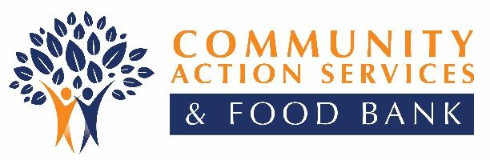
815 S. Freedom Blvd.
Suite 100
Provo, UT 84601
P: (801) 373-8200
F: (801) 373-8228
CommunityActionUC.org

Job Announcement
TITLE: Food Bank Truck Driver
SALARY: $14.50 to $15.00/hour, 20 hours weekly, part time (M–F)

Community Action Services and Food Bank is looking for a self-motivated individual who wants to make a difference in life. This is a part-time driver position to run a weekly route picking up donations from food drives and donations from grocery stores. This is a fulfilling job. The position does not require a CDL but does require a DOT medical card. If you feel you are the right candidate, please apply as outlined below.

DUTIES AND RESPONSIBILITIES
- Strictly adhere to all CASFB policies and procedures
- Greet donors and volunteers at warehouse entrance and assist as needed
- Drive trucks in support of food pickup, deliveries, food drives, and other food bank operational needs
- Obey all traffic laws and be a safe, courteous driver
- Maintain a clean, properly serviced, and safe truck
- Perform basic computer operations
- Ensure that work areas are organized, clean, safe, and free of clutter
- Document donation and disbursements accurately
- Present a positive image to donors, volunteers, clients, and staff
- Work closely with other team members to maintain a smooth and efficient operating program
- Submit all documentation in a timely manner (timesheets, discard logs, mileage, etc.)
- Perform sidewalk and snow removal, trash removal, yard work, and parking lot clean up as needed
- Perform work to support successful food drives as directed
- Accept extra assignments as needed or requested
- Maintain a cheerful and courteous service relationship with store personnel, school officials, volunteers, donors, clients, staff, and administrators

FACTORS
- Ability to lift up to 80 lbs. on a regular basis
- Be honest, fair, and straightforward in handling and disbursing donations
- Oral and written English communication skills
- Excellent customer service skills
- Ability to problem solve
- Ability to work in demanding and stressful situations
- Ability to work in high-volume periods of activity on any given day or time of the year
- Ability to work as a team player
- Willingness to follow directions
- Be dependable, motivated, and a self-starter, flexible and able to work occasional evenings and weekends
- A valid Utah driver’s license, a clean driving record, and reliable transportation and DOT medical card
- Ability to become forklift certified
- Ability to speak Spanish (helpful)

The Community Action application must be completed and submitted with your resume for first review. The position is open until filled. The application can be downloaded at our website: www.communityactionprovo.org/. We are located at 815 S. Freedom Blvd., Suite 100, Provo, UT 84601, and can be reached at (801) 373-8200. Community Action Services and Food Bank is an Equal Opportunity Employer.

Food Bank/Food Pantry ● Homebuyer & Mortgage Counseling Services ● Support Services ● Family Development ● Circles Initiative

Our Partner in Caring

